How to import .CHplugin file to Chitubox?

A.

1. Download .CHplugin file form Github . file name like “bean_plugin.CHplugin”

<https://github.com/JNJ3D/Kudo3D-Bean-3D-Printer-Plugin>

<https://github.com/JNJ3D/CWS-plugin-8bit>

<https://github.com/JNJ3D/CWS-plugin-32bit>

2. Run Chitubox

3. Select **MENU** 🡪 **Plugin** 🡪 select **Import Plugin**

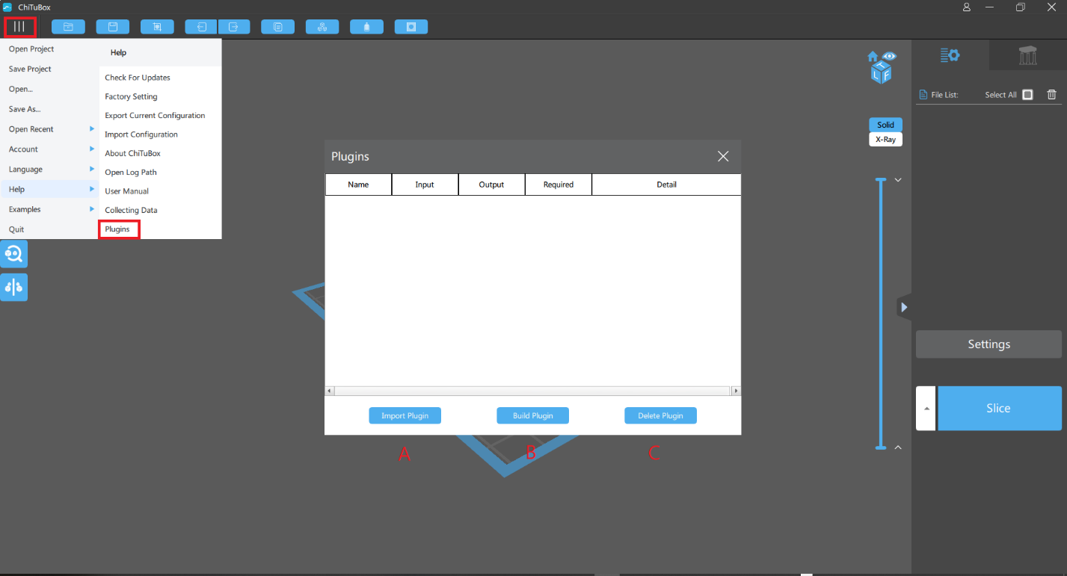

4. select your download “bean_plugin.CHplugin” file location, then select bean_plugin.CHplugin. 🡪 Open

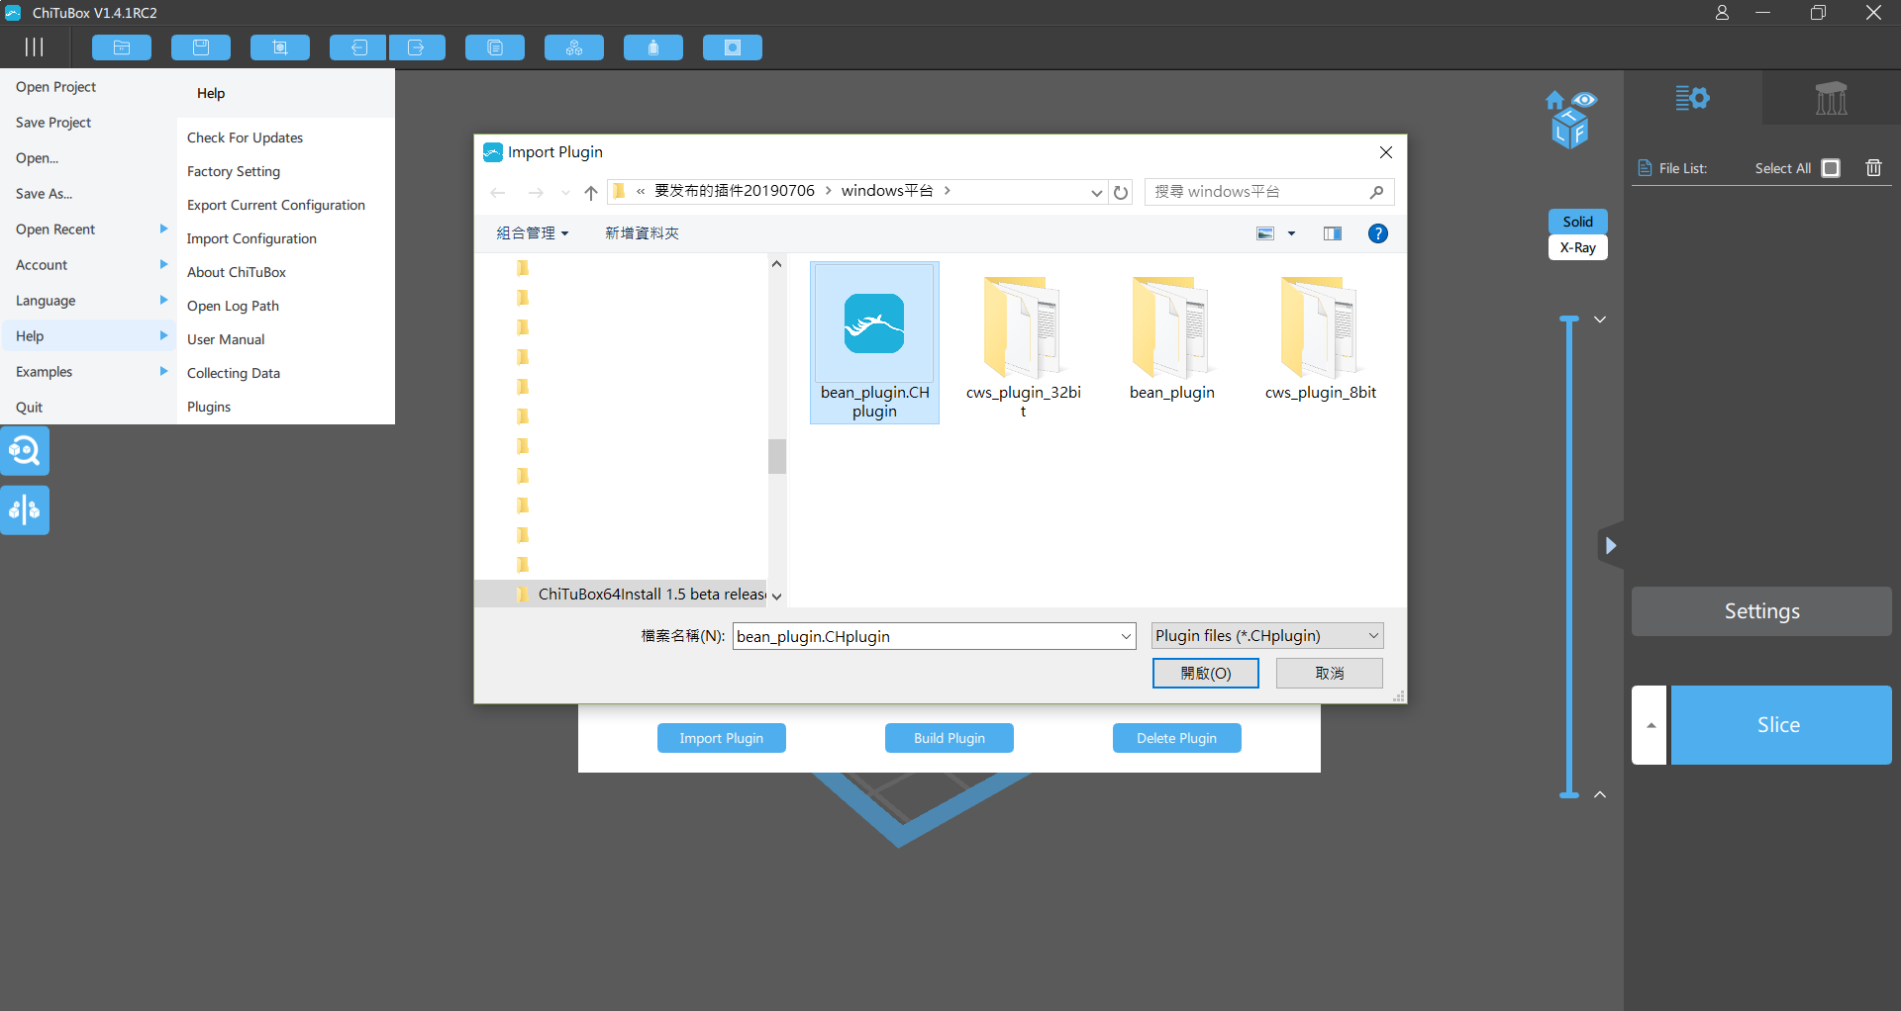

5. bean_plugin.CHplugin already imported. Click the X in the upper right corner to close the dialog box.

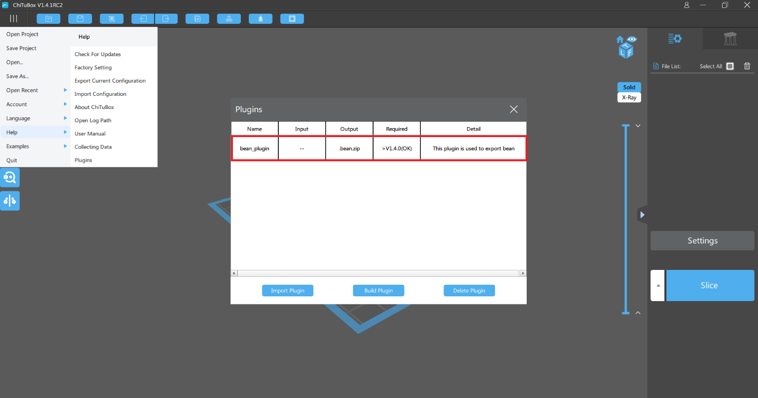

6. You can open STL file to Chitubox , to slicer model , A finish slicer can save as the bean machine file format. Like XXXXXXXX.bean.zip

